|  |
| --- |
| **Efnaúrgangur**  **til förgunar** |
| Deild: |
| Sími: |
| Viðfangsnúmer: |
| Tengiliður: |
| Dagsetning: |
|  |

Innihald:

|  |  |  |  |  |
| --- | --- | --- | --- | --- |
| **UN númer** | **Innihald í blöndu** | **Hlutfall** | **Númer varúðar**  **merkja** | **Pökkunar**  **flokkur** |
| UN 1307 | XÝLEN | 60-90% | 3 | III |
| UN 1170 | ETANÓL | 10-40% | 3 | II |

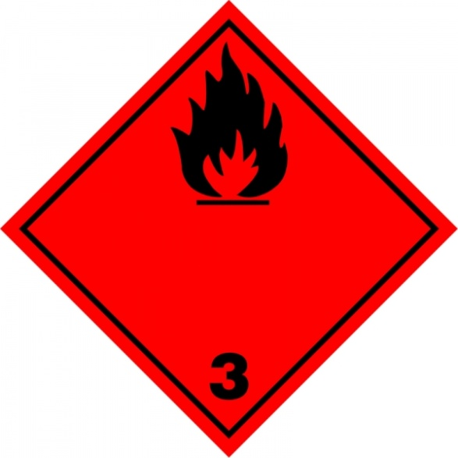

# LHS_isl_lit

|  |
| --- |
| **Efnaúrgangur**  **til förgunar** |
| Deild: |
| Sími: |
| Viðfangsnúmer: |
| Tengiliður: |
| Dagsetning: |
|  |

Innihald:

|  |  |  |  |  |
| --- | --- | --- | --- | --- |
| **UN númer** | **Innihald í blöndu** | **Hlutfall** | **Númer varúðar**  **merkja** | **Pökkunar**  **flokkur** |
| UN 1307 | XÝLEN | 60-90% | 3 | III |
| UN 1170 | ETANÓL | 10-40% | 3 | II |





Hættumerki

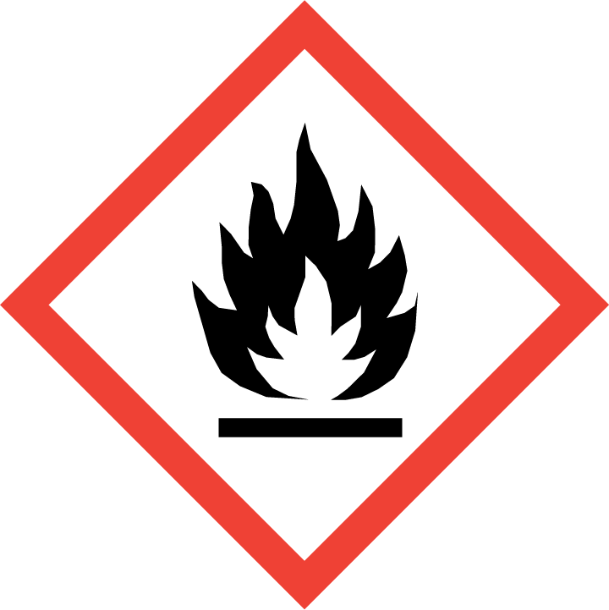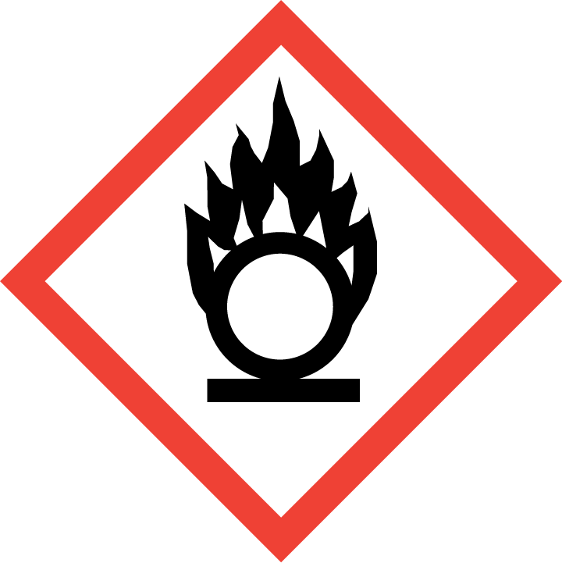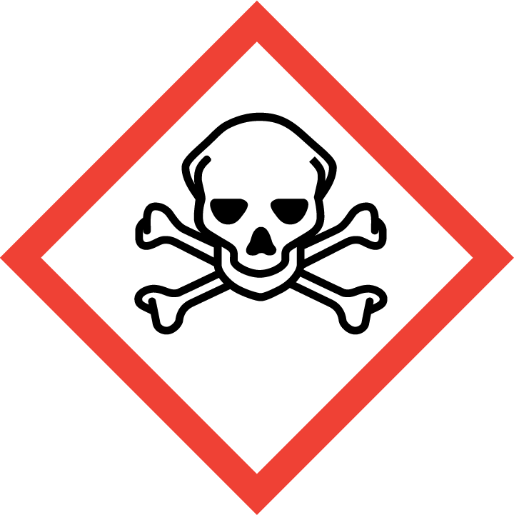

ADR merki

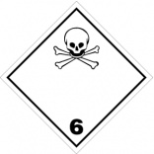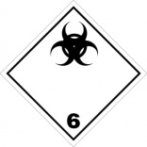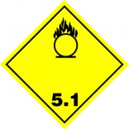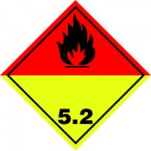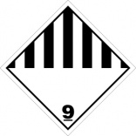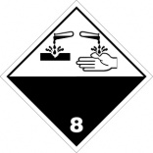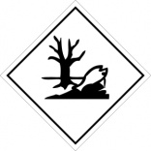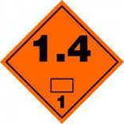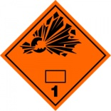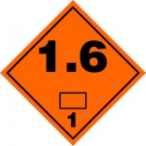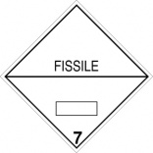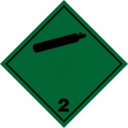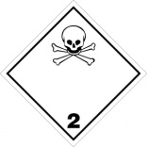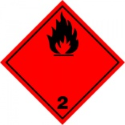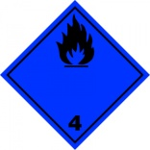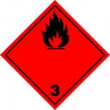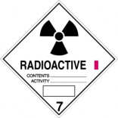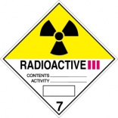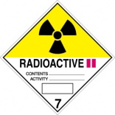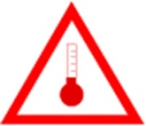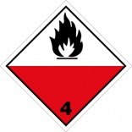

|  |
| --- |
| **Efnaúrgangur**  **til förgunar** |
| Deild: |
| Sími: |
| Viðfangsnúmer: |
| Tengiliður: |
| Dagsetning: |
| Innihald:   |  |  |  |  |  |  | | --- | --- | --- | --- | --- | --- | | **Efnisþáttur** | **UN númer** | **Innihald blöndu** | **Hlutfall** | **Hættumerki** | **ADR merki** | | Súbstrat | Á ekki við | 3,3′,5,5′-Tetramethylbenzidine <0,05% í vatni eða sítratbuffer | 40-50% | GHS07 |  | | UN 1673 | o-Phenylenediamine dihydrochloride, 1 mg/ml | 40% | GHS09.gifGHS06.gifGHS08 | toxic-substances-class61-6102all25-6102all30-6102a10-6102a25-6102a30_t1.jpg  environmentally-hazardous-substance-6130all30-6130a30_t1 | | Stopplausn | UN 2796 | Brennisteinssýra <1N (m/v 25%) | 50-60% | GHS05.gif | corrosive-substances-class8-6116all25-6116all30-6116a10-6116a25-6116a30_t1 | | UN 1805 | Fosfórsýra, 1M (m/v 42,5%) | 50% |   **LHS_isl_lit** |

|  |
| --- |
| **Efnaúrgangur**  **til förgunar** |
| Deild: |
| Sími: |
| Viðfangsnúmer: |
| Tengiliður: |
| Dagsetning: |
| Innihald:   |  |  |  |  |  |  | | --- | --- | --- | --- | --- | --- | | **Efnisþáttur** | **UN númer** | **Innihald blöndu** | **Hlutfall** | **Hættumerki** | **ADR merki** | | Súbstrat | Á ekki við | 3,3′,5,5′-Tetramethylbenzidine <0,05% í vatni eða sítratbuffer | 40-50% | GHS07 |  | | UN 1673 | o-Phenylenediamine dihydrochloride, 1 mg/ml | 40% | GHS09.gifGHS06.gifGHS08 | toxic-substances-class61-6102all25-6102all30-6102a10-6102a25-6102a30_t1.jpg  environmentally-hazardous-substance-6130all30-6130a30_t1 | | Stopplausn | UN 2796 | Brennisteinssýra <1N (m/v 25%) | 50-60% | GHS05.gif | corrosive-substances-class8-6116all25-6116all30-6116a10-6116a25-6116a30_t1 | | UN 1805 | Fosfórsýra, 1M (m/v 42,5%) | 50% |   **LHS_isl_lit** |